Step 1: Go to Bell Ringers  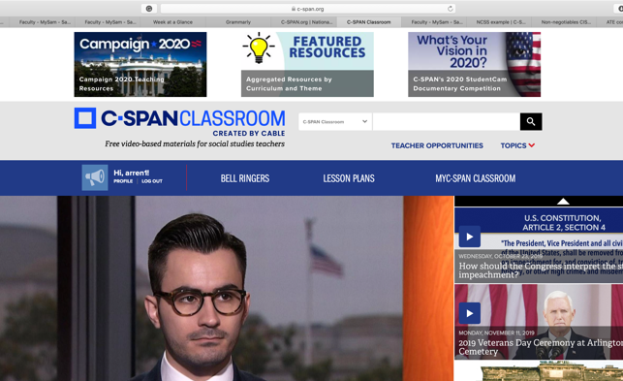 | Step 2: Once on this page select Create Document  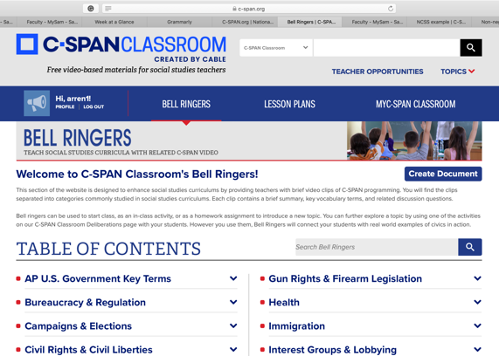
Step 3: Fill in required information  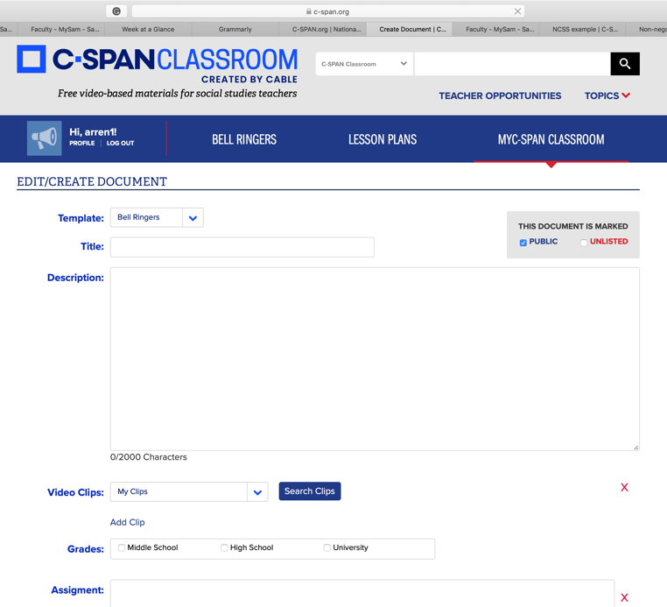 | Step 4: Click Search clips (your videos appear here) select the video you like.  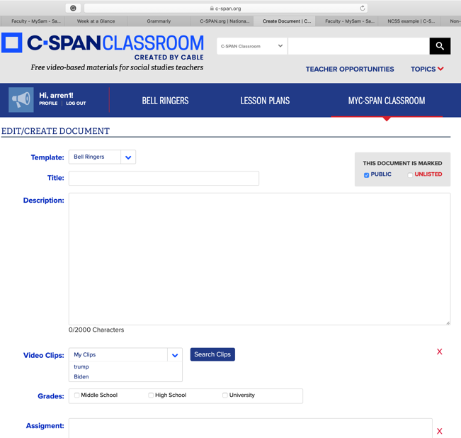
Step 5: Select add clip if you have more than one video and write your questions in the assignment box.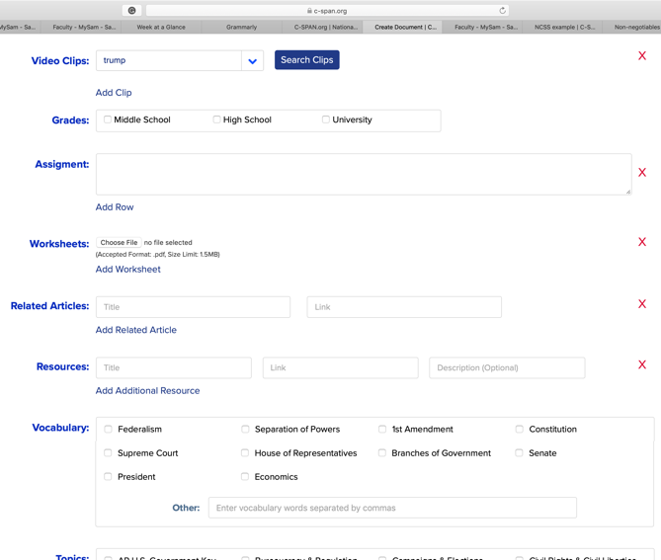 | Step 6: Click the vocab terms your bell ringer is related to and the topic. Click to agree to C-SPAN’s terms, then click submit.
Step 7: Your Bell Ringer is created. Copy and paste the URL if you desire. | Step 8: Go to MYC-SPAN CLASSROOM to access your created materials in the future.

