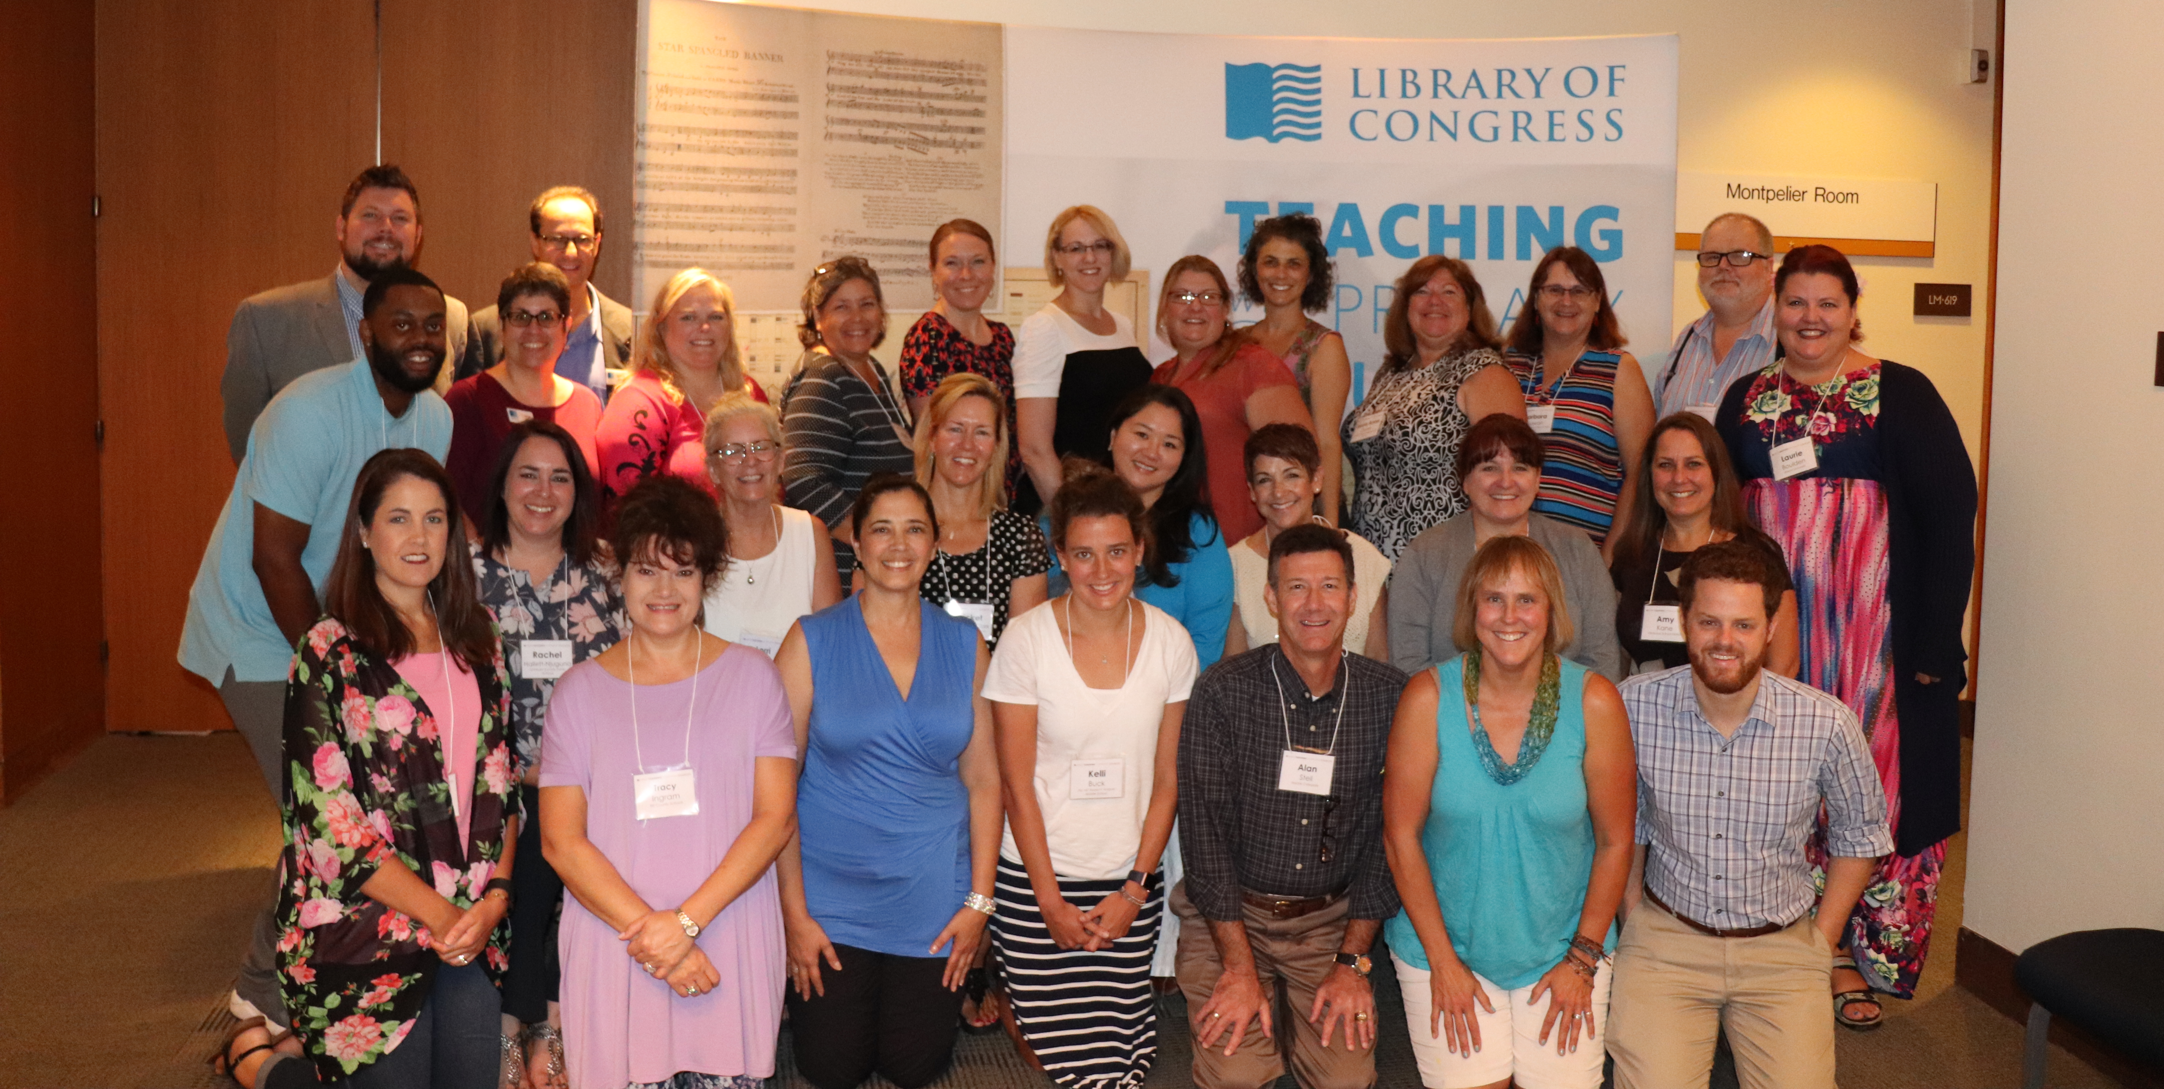  Professional Development Opportunity  June 5-7, 2019  Powerful Teaching with Primary Documents  Critical thinking, complex text, and student engagement are hot topics for classroom success. This professional development program, based on the Library of Congress model, will provide tools for practical classroom application.  Room and board will be provided if needed. Materials and resources to implement classroom application, valued at $75, will be provided upon successful completion of the initial training. Participants will also receive a PD Certificate for 30 hours after the conclusion of the fall reflection.  The PD program is appropriate for educators and pre-service teachers grades K-12 in many disciplines. Sessions will demonstrate applications of primary sources in multiple academic areas. College credit will be available for purchase.  This program is sponsored in part by the Library of Congress Teaching with Primary Sources Eastern Regional Program, coordinated by Waynesburg University.  Please submit applications by February 28th using an email through which we can communicate without being blocked. | Immerse yourself in the practice of teaching with Primary Sources using the Library of Congress.  Daily sessions model strategies to engage students, build critical thinking skills, and construct knowledge.  Goals include access and use of primary sources for critical thinking lessons. A final product will be to design a lesson plan for implementing in the fall.  Warner university  13895 Highway 27  Lake Wales, FL 33859  For more info call:  863-638-7118  June 5-7, 2019  9am to 5pm  Breakfast, lunch, and dinner included  Evenings are free.  For an application, please email  prodevelopment@warner.edu

